**CALIFORNIA STATE UNIVERSITY, LONG BEACH**

College of Engineering

Department of Computer Engineering and Computer Science

Mr. Haney Williams

**CECS-326:** Operating Systems

PROJECT 1

BINARY TREE OF PROCESSES

Pan Amanda

Name: ____________________________________

Last, First

ABSOLUTELY NO LATE PROJECTS WILL BE ACCEPTED

**PROJECT DESCRIPTION:**

Write a program using C/C++ to generate a binary tree of processes. The input to the program includes the number of levels in the tree. The maximum number of levels is 5, but the program should work for a general case of any number. Use command line arguments.

Example of a program run is as follows: **ecs416lin213.cecs.csuld.edu:1>p1 4**

Level Procs Parent Child 1 Child 2

|  |  |  |  |  |
| --- | --- | --- | --- | --- |
| No. | ID | ID | ID | ID |
| 0 | 3608 | 3574 | 3609 | 3610 |
| 1 | 3610 | 2608 | 3612 | 3613 |
| 1 | 3609 | 3608 | 3611 | 3614 |
| 2 | 3612 | 3610 | 3616 | 3617 |
| 2 | 3614 | 3609 | 3620 | 3621 |
| 2 | 3611 | 3609 | 3615 | 3622 |
| 2 | 3613 | 3610 | 3618 | 3619 |
| 3 | 3620 | 3614 | 3629 | 3630 |
| 3 | 3622 | 3611 | 3633 | 3634 |
| 3 | 3615 | 3611 | 3623 | 3635 |
| 3 | 3616 | 3612 | 3624 | 3625 |
| 3 | 3617 | 3612 | 3626 | 3636 |
| 3 | 3618 | 3613 | 3627 | 3637 |
| 3 | 3619 | 3613 | 3628 | 3638 |
| 3 | 3621 | 3614 | 3631 | 3632 |

**DOCUMENTATION:**

The project must be carefully documented. The write-up must include: one page of problem analysis and discussion (include a flow chart or structure chart when relevant), program listing with proper comments, one page of output listing using N = 3. Draw a tree diagram showing the process IDs in circles. The discussion should include general considerations, UNIX/LINUX function calls, any reasonable assumptions, and any other relevant information. Attach this sheet as the front page of your project. Firmly staple the entire project together. No folder is used.

**NOTES**:

1. After submitting the project, do not change, edit, or recompile the program. Violations of this rule will result in the project being graded zero.
2. Discussions among students are encouraged, but only to the extent of clarifying the problem statement and/or the general approach to the problem as discussed in class. The project must represent your own work.

END OF PROJECT 1

**Problem Analysis:**

The problem uses only *proj1* program. The program generates a binary tree of a maximum of 5 levels, depending on the input of the user. The process creates two child process using *fork()*.

**Discussion:**

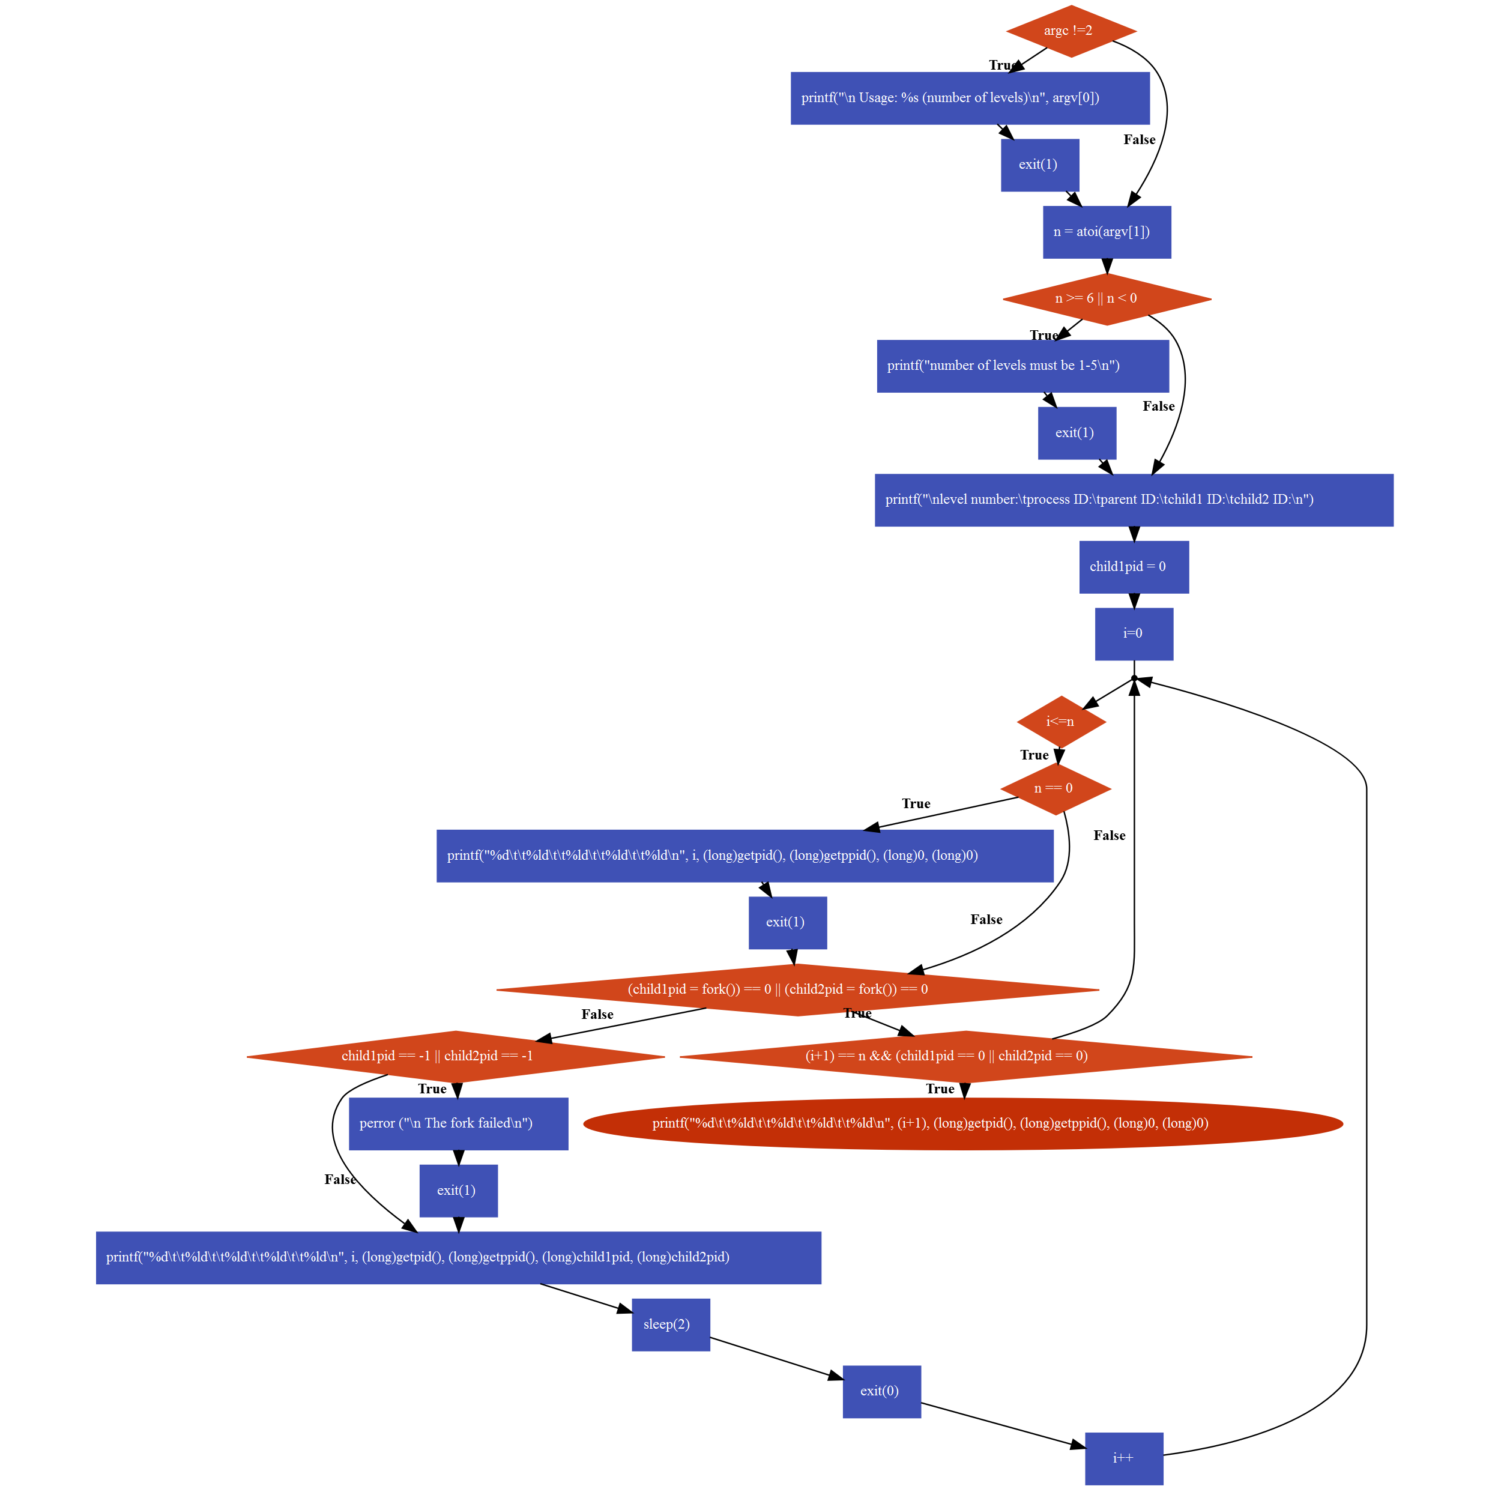

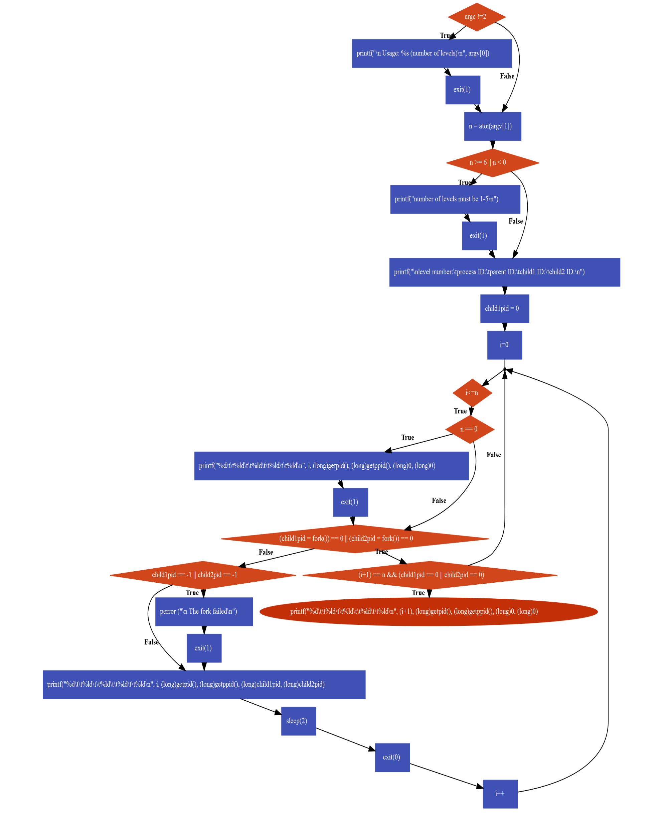

**Programing Listing:**

/**************************************************************************/

/* PROGRAM: proj1.c */

/* DESCRIPTION: This program generates a binary tree */

/* using fork(). The number of levels n is a command line argument. */

/* Each process sleeps for 2 seconds then prints out */

/* Level number, process ID, parent ID, child1 ID, and child2 ID */

/**************************************************************************/

# include <stdio.h>

# include <stdlib.h>

# include <sys/types.h>

# include <unistd.h>

# include <sys/wait.h>

# include <signal.h>

int main**(**int argc**,** char **\***argv**[])**

**{**

int i**,** n**;**

pid_t child1pid**,** child2pid**;**

//if argument entered is not 2, prompt error and exit

**if** **(**argc **!=**2**)** **{**

printf**(**"\n Usage: %s (number of levels)\n"**,** argv**[**0**]);**

exit**(**1**);**

**}**

n **=** atoi**(**argv**[**1**]);** //n takes in the second argument

//value of n must be between 1-5, or else exit

**if** **(**n **>=** 6 **||** n **<** 0**)** **{**

printf**(**"number of levels must be 1-5\n"**);**

exit**(**1**);**

**}**

printf**(**"\nlevel number:\tprocess ID:\tparent ID:\tchild1 ID:\tchild2 ID:\n"**);**

child1pid **=** 0**;**

**for** **(**i**=**0**;** i**<=**n**;** i**++)** **{**

**if** **(**n **==** 0**)**

**{**

printf**(**"%d\t\t%ld\t\t%ld\t\t%ld\t\t%ld\n"**,** i**,** **(**long**)**getpid**(),** **(**long**)**getppid**(),** **(**long**)**0**,** **(**long**)**0**);**

exit**(**1**);**

**}**

//if either child pid is 0, continue the loop

**if** **((**child1pid **=** fork**())** **==** 0 **||** **(**child2pid **=** fork**())** **==** 0**)** **{**

//if child pid is the last level, print to show that it is a leaf

**if((**i**+**1**)** **==** n **&&** **(**child1pid **==** 0 **||** child2pid **==** 0**))**

**{**

**return** printf**(**"%d\t\t%ld\t\t%ld\t\t%ld\t\t%ld\n"**,** **(**i**+**1**),** **(**long**)**getpid**(),** **(**long**)**getppid**(),** **(**long**)**0**,** **(**long**)**0**);**

**}**

**continue;**

**}**

//if child pid is 1-, fork failed and exit

**if** **(**child1pid **==** **-**1 **||** child2pid **==** **-**1**)** **{**

perror **(**"\n The fork failed\n"**);**

exit**(**1**);**

**}**

printf**(**"%d\t\t%ld\t\t%ld\t\t%ld\t\t%ld\n"**,** i**,** **(**long**)**getpid**(),** **(**long**)**getppid**(),** **(**long**)**child1pid**,** **(**long**)**child2pid**);**

sleep**(**2**);** //process sleeps for 2 seconds

exit**(**0**);**

**}**

**}**

**Output Program:**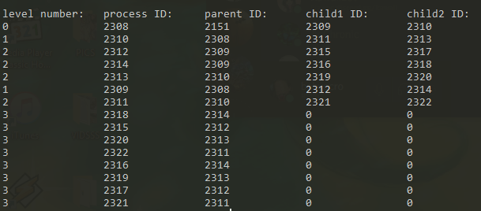

**Tree diagram:**

